The Spooose Jet Fighter

vs

The Nazi Monster
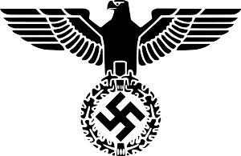

Captain John Seena was in the left seat of the Spooose Fighter in the Year of the Asteroid Blitz 6021. 008 when it was returning to the planet of Messerschmitt, a former Nazi stronghold before the Great War of the Outer Planets. The fighter had been on patrol around the Emerald Galaxy which had recently been threatened by hostile forces from the nearby Onyx Galaxy.

The fighter was being repaired, but just as the flight mechanic was finishing his job on the engine, he was devoured by a strange monster!! The man-eating monster had been created during the Great War and it had never been destroyed. Now it was threatening the lives of Captain Seena and his entire crew!

Captain Seena sent a distress call and The Storm Troopers arrived from the planet of Messerschmitt. Unfortunately, three of them were killed by the Monster. The first was eaten whole. The second one was eaten slowly. The third one had his helmet pulled off and suffocated. The rest of the Troopers were horrified and only one was brave enough to fight the Monster face-to-face.

It was the

famous Sergeant Dumbey.

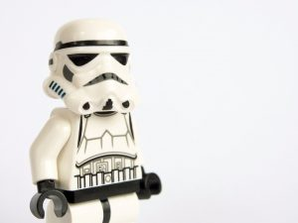

As soon as he stepped off of the transporter, Dumbey was dragged by the Monster to the crater of a volcano filled with lava!!! As he tossed the unfortunate Dumbey into the crater, the Monster yelled, “I like my Storm Troopers well-done!” Everyone thought Dumbey was done, really DONE and not just well-done.

He survived this terrible ordeal, however, but only briefly. The heartless Monster grabbed hold of his charred body and dipped him into a cauldron filled with barbecue sauce, ketchup, mustard, and ranch dressing. With one enormous gulp, the Monster ate him! Then he licked his lips and said, “That was delicious! I want more well-done Storm Troopers!

“We can’t give up! We must keep on fighting!” screamed Captain Seena. Now the Storm Troopers were ready to fight. They stormed up the Volcano where the ugly Monster stood with a hungry look in his eyes. The Troopers fired their biggest canon, The Great Gustaf 3.05, right at him. Luckily, the immense canon ball hit him and killed him instantly.
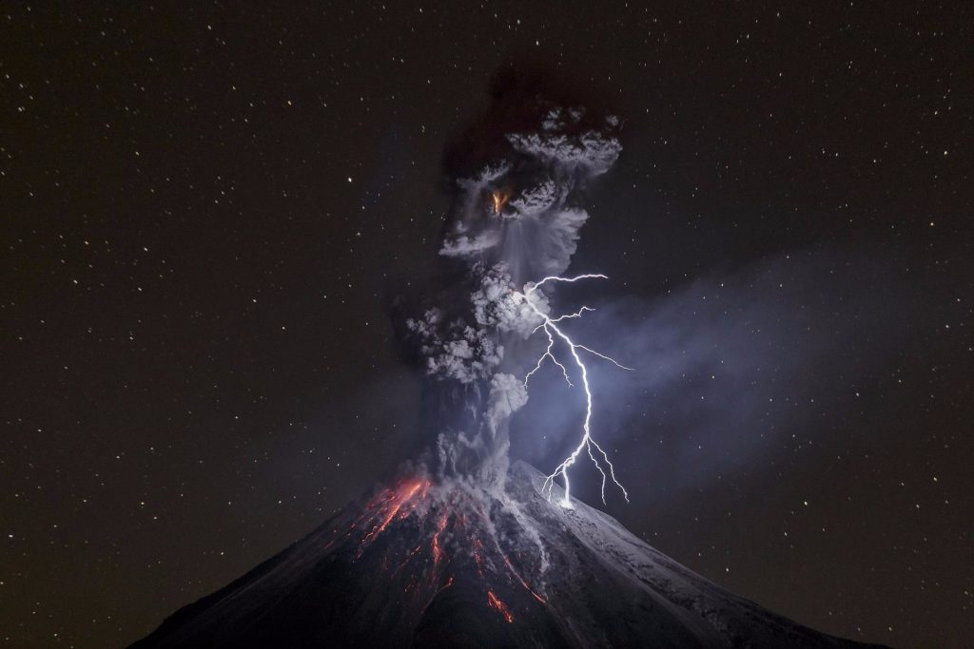

“Hurray!” screamed the Troopers. “Let’s have a Nazi Monster Barbeque!” They tossed the monster’s body into the volcano and a few minutes later the volcano spit out a very well-done Nazi Monster.

“Yum!” said all the Storm Troopers.

“Pass the barbecue sauce!” commanded Captain Seena.
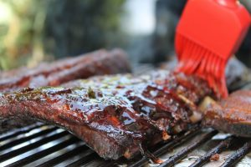

He and all the Storm Troopers ate until they were full. Then they made their way back to the Command Post and lived happily ever after.

The End

